# **CTF Topic: Website Analysis Wappalyzer**

**Introduction**



In Capture The Flag (CTF) challenges, analyzing websites can help identify technologies. Wappalyzer is a tool that detects the technologies used on a website, such as content management systems (CMS), web servers, and JavaScript frameworks.

# **Tools and requirements**

HackerTarget Wappalyzer tool kit

# **Scenario**

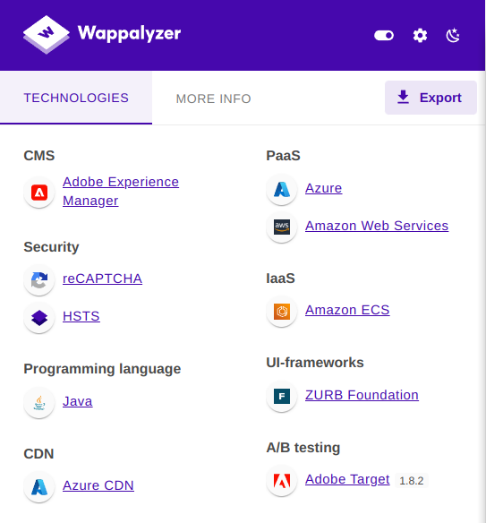

Imagine participating in a CTF challenge where you are given a URL to a website. Your task is to analyze the website, identify the technologies in use, and gather information that might help you find potential vulnerabilities or clues leading to the next step in the challenge.

# 

# **Process to Perform**

Step 1: Go to your browser and click on the provided link: <https://hackertarget.com/whatweb-scan/>

Step 2: Copy <http://altoro.testfire.net/login.jsp> and paste it to the Http/Https Test field.

# **Let’s start the Challenge**

# **Question**

Flag1: what is the server used by the website ?

Answer: Apache Tomcat

Flag2: what is the ip address of this website ?

Answer: 65.61.137.117

# **Hint**

